High Level Design (HLD)
Telecom Churn Analytics
Business Intelligence

Harshad Khedekar

DOCUMENT VERSION CONTROL:

Date Issued | Version | Description | Author
01th June 2021 | 1.0 | First Version of Complete HLD

CONTENTS
Sr.No | Content | Page No.
 | Document Version Control | 2
 | Abstract | 4
1. | Introduction | 5
1.1 | Why this high level design document? | 5
1.2 | Scope | 5
2. | General description | 6
3. | Design details | 7
3.1 | Functional Architecture | 8
3.2 | Optimization | 8
4. | KPI s | 9
5. | Deployment | 9

ABSTRACT

The churn is defined as the rate of attrition, is the percentage of subscribers to a service who discontinue their subscriptions to that service within a given time period.
Telecom Churn is a burning problem for Telecom companies. The data (mta-customer-feedback-data-beginning-2014-1.csv) has information about the Agency, Commendation or Complaint, Subject Matter, Subject Detail, Issue Detail, Year, Quarter, Branch/Line/Route. The data also indicates which the customers review on service with the area and agency. Based on this past data, we need to build a model which can predict whether a customer will cancel their service in the future or not based on their reviews.

1 Introduction

1.1 Why this High-Level Design Document?
The purpose of this High-Level Design (HLD) Document is to add the necessary detail to the
current project description to represent a suitable model for coding. This document is also
intended to help detect contradictions prior to coding, and can be used as a reference manual
for how the modules interact at a high level.

The HLD will:
• Present all of the design aspects and define them in detail
• Describe the user interface being implemented
• Describe the hardware and software interfaces
• Describe the performance requirements
• Include design features and the architecture of the project
• List and describe the non-functional attributes like:
- Security
- Reliability
- Maintainability
- Portability
- Reusability
- Application compatibility
- Resource utilization
- Serviceability

1.2 Scope
The HLD documentation presents the structure of the system, such as the database
architecture, application architecture (layers), application flow (Navigation), and technology
architecture. The HLD uses non-technical to mildly-technical terms which should be
understandable to the administrators of the system.

2. General Description

2.1 Product Perspective & Problem Statement
Housing prices are an important reflection of the economy, and housing price ranges are of great interest for both buyers and sellers. In this project, house prices will be predicted given explanatory variables that cover many aspects of residential houses.
The objective of the project is to perform data visualization techniques to understand the insight of the data. This project aims apply various Business Intelligence tools such as Tableau
or Power BI to get a visual understanding of the data.

2.2 Tools used

Business Intelligence tools and libraries works such as Power BI are used to build the whole framework.

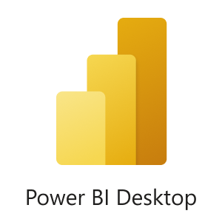
3. Design Details

3.1 Functional Architecture

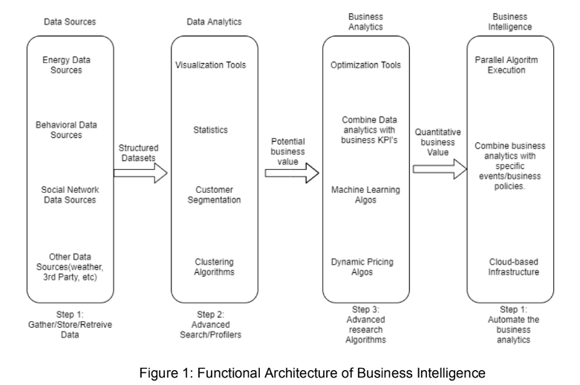

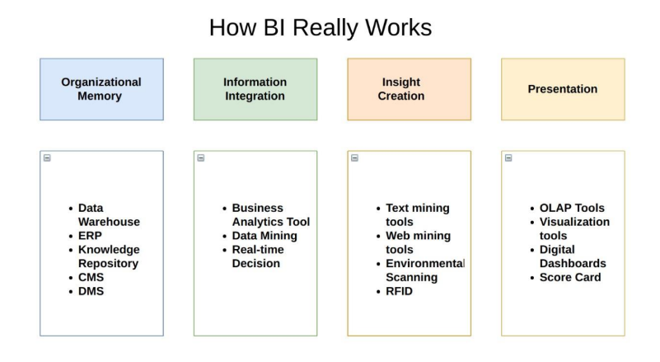

3.2 Optimization

Your data strategy drives performance
• Minimize the number of fields
• Minimize the number of records
• Optimize extracts to speed up future queries by materializing calculations, removing
columns and the use of accelerated views

Reduce the marks (data points) in your view
• Practice guided analytics. There’s no need to fit everything you plan to show in a single view. Compile related views and connect them with action filters to travel from overview
to highly-granular views at the speed of thought.
• Remove unneeded dimensions from the detail shelf.
• Explore. Try displaying your data in different types of views.

Limit your filters by number and type
• Reduce the number of filters in use. Excessive filters on a view will create a more
complex query, which takes longer to return results. Double-check your filters and
remove any that aren’t necessary.
• Use an include filter. Exclude filters load the entire domain of a dimension, while
include filters do not. An include filter runs much faster than an exclude filter, especially
for dimensions with many members.
• Use a continuous date filter. Continuous date filters (relative and range-of-date filters)
can take advantage of the indexing properties in your database and are faster than
discrete date filters.
• Use Boolean or numeric filters. Computers process integers and Booleans (t/f) much
faster than strings.
• Use parameters and action filters. These reduce the query load (and work across data sources).
Optimize and materialize your calculations
• Perform calculations in the database
• Reduce the number of nested calculations.
• Reduce the granularity of LOD or table calculations in the view. The more granular
the calculation, the longer it takes.
- LODs - Look at the number of unique dimension members in the calculation.
- Table Calculations - the more marks in the view, the longer it will take to
- calculate.

• Where possible, use MIN or MAX instead of AVG. AVG requires more processing
than MIN or MAX. Often rows will be duplicated and display the same result with
MIN, MAX, or AVG.
• Make groups with calculations. Like include filters, calculated groups load only
named members of the domain, whereas Tableau’s group function loads the entire
domain.
• Use Booleans or numeric calculations instead of string calculations. Computers can
process integers and Booleans (t/f) much faster than strings.
Boolean>Int>Float>Date>DateTime>String

4. KPIs
Dashboards will be implemented to display and indicate certain KPIs and relevant indicators
for the disease.
As and when, the system starts to capture the historical/periodic data for a user, the dashboards will be included to display charts over time with progress on various indicators or factors.

4.1 KPIs (Key Performance Indicators)
Key indicators displaying a summary of the Telecom churn and its relationship with different
Metrics.

5. Deployment
Prioritizing data and analytics couldn’t come at a better time. Your company, no matter what
size, is already collecting data and most likely analyzing just a portion of it to solve business problems, gain competitive advantages, and drive enterprise transformation. With the explosive growth of enterprise data, database technologies, and the high demand for analytical skills, today’s most effective IT organizations have shifted their focus to enabling self-service by deploying and operating Power BI at scale, as well as organizing, orchestrating, and unifying disparate sources of data for business users and experts alike to author and consume content.

Pros of Power BI
Let us discuss some of the most essential advantages of Power BI which plays a key role in making Power BI a successful tool.

1. Affordability
A major advantage of using Power BI for data analysis and visualization is that it is affordable and relatively inexpensive. The Power BI Desktop version is free of cost. You can download and start using it to make reports and dashboards on your computer. However, if you want to use more Power BI services and publish your reports on the cloud, you can take the Power BI Cloud service solution for $9.99 per user per month. Thus, Power BI is offered at a fair price as compared to other BI tools.

2. Custom Visualizations
Power BI offers a wide range of custom visualizations i.e. visualizations made by developers for a specific use. Custom visuals are available on Microsoft marketplace. In addition to the general set of visualizations available you can use Power BI custom visualizations in your reports and dashboards. The range of custom visualizations includes KPIs, maps, charts, graphs, R script visuals, etc.

3. Excel Integration
In Power BI, you also have the option to upload and view your data in Excel. You can select/filter/slice data in a Power BI report or dashboard and put it on Excel. You can then open Excel and view the same data in tabular form in an Excel spreadsheet. In other words, Power BI’s capability of Excel integration helps users to view and work with the raw data behind a Power BI visualization.

4. Data Connectivity
Another major advantage of using Power BI as your data analysis tool is that you can import data from a wide range of data sources. It offers data connectivity to data files (such as XML, JSON), Microsoft Excel, SQL Server databases, Azure sources, cloud-based sources, online services such as Google Analytics, Facebook, etc. In addition to all this, Power BI can also access Big Data sources directly. Thus, you will get all sorts of data sources to connect to and get data for analysis and report making.

5. Prompt Updates
Power BI gets upgrades from Microsoft every month. Microsoft has made a user community where users can upload their suggestions and tweaks about Power BI. The suggestions that get the most rating by other users have a good chance of getting included in the next update of Power BI. A Power BI user will get notified every time a new update comes which they can easily download. Due to the prompt and inclusive upgrading system, Power BI is able to include better functionalities since its release.

6. Power BI Embedded
Power BI Embedded is another positive aspect of Power BI. Using this solution, an app developer can embed or include Power BI reports and features into web-based or other apps. By using this, we can add Power BI visuals and reports into emails or websites to increase its reach to users.

7. Personal Gateway
We have talked about gateways in Power BI and their use in earlier tutorials. Personal Gateway is a tool which you can use with Power BI to authenticate data sources that are on-premise and outside the firewall. Once this tool authenticates an on-premise data source, a cloud-hosted Power BI instance can use data from that data source.

8. Data Accessibility
Power BI offers great accessibility to data sources and the data sets that you create while designing reports. All the data that you import from data sources and work with is stored in a centralized location. You can access that data anytime, from anywhere, from any platform and as many times as you want.

9. Interactive Visualizations
The most talked-about advantage of Power BI over any other data visualization tool is its attractive, intuitive and interactive visualizations. We can use Power BI’s easy drag-and-drop functionality to add different visualizations in a report. Also, we can interact with visualization by applying filters, making selections in it, etc. It is very easy to create and understand data through visualizations in Power BI.

Any queries in the Power BI advantages? Mention them in the comment section.

Cons of Power BI
After the advantages, it’s time to throw some light on the disadvantages of Power BI.

1. Table Relationships
Power BI is good with handling simple relationships between tables in a data model. But, if there are complex relationships between tables, that is, if they have more than one links between tables, Power BI might not handle them well. You need to create a data model carefully by having more unique fields so that Power BI does not confuse the relationships when it comes to complex relationships.

2. Configuration of Visuals
In most cases, you might not feel the need to configure and optimize visualizations in Power BI. But even if you do, Power BI does not provide many options to configure your visualizations as per your requirements. Thus, users have limited options for what they can change in visuals.

3. Crowded User Interface
The user interface of Power BI is often found crowded and bulky by the users. It is in the sense that there are many icons of options that block the view of dashboard or report. Most users wish that the user interface or the report canvas was clearer with fewer icons and options. Also, creating scrolling dashboards is a native feature.

4. Rigid Formulas
As we know, the expression language used to deal with data in Power BI is DAX. However, you can perform a lot of actions using the DAX formula in Power BI, it is still not the easiest language to work with. Sometimes the formulas you create work well in Power BI, sometimes they don’t. You can concatenate up to two elements but concatenating more than two elements needs nesting statements.

5. Handling Large Data Volumes
Power BI has a limit of ingesting data at a time which is approximately 2 GBs of data. If you wish to import and use data of even greater volumes, you need to extend your free version to a paid version of Power BI. Also, users have reported that Power BI takes a little more than usual time or even hangs while processing millions of rows and columns of data.

6. Complex to Understand and Master
Usually, Power BI is the easiest to use BI tool if you are using it simply to import data and create reports. But Power BI is an entire suite having a lot of other interrelated tools. When the purpose of your use is more than just creating reports in Power BI Desktop, you need to learn and master several other tools like Gateways, Power BI Report Server, Power BI Services, etc.

This concludes our discussion on the pros and cons of Power BI. Even after going through some of Power BI general disadvantages, we are certain that Power BI is a great tool for data visualization and data analysis. Moreover, Power BI is constantly working on to make improvements in it so we can expect better versions to come.

